Welcome to
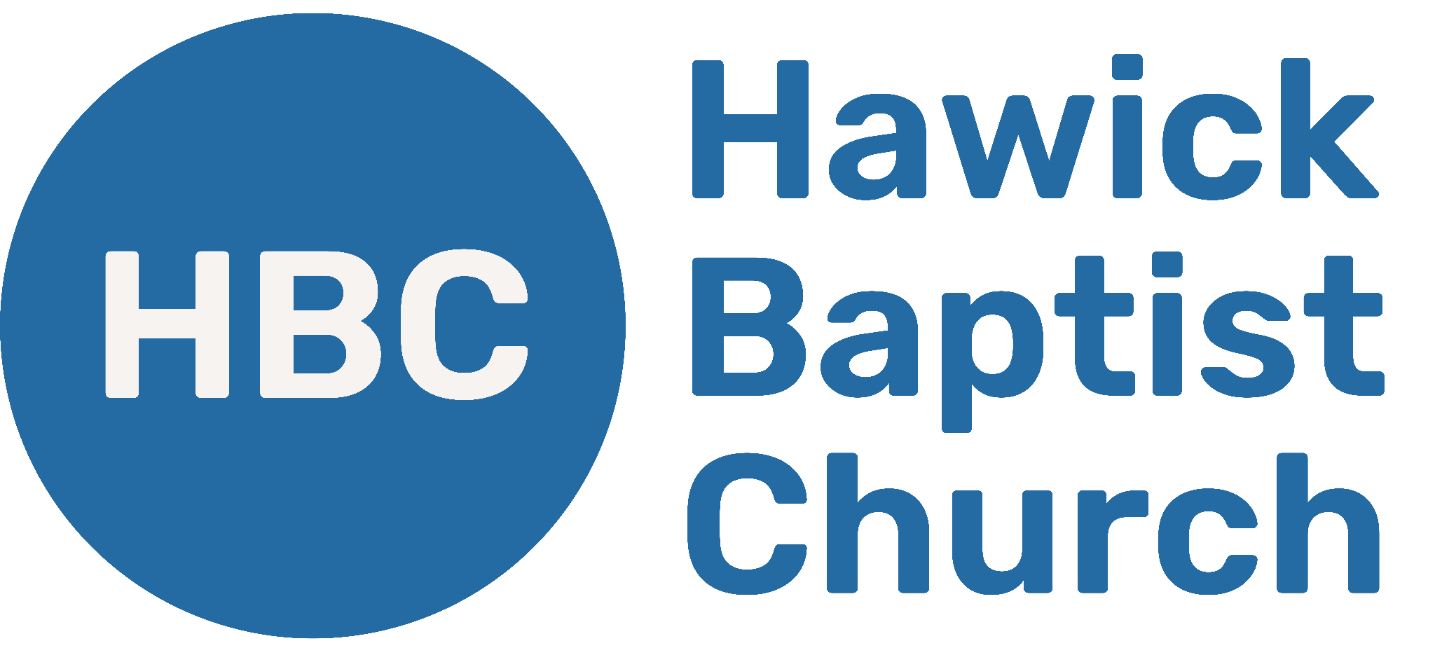
Sunday, 13 July 2025

TODAY’S SONGS
Psalm 100,
Yet Not I but Through Christ in Me,
Voices,
Hear the Call of the Kingdom,
Christ Our Hope in Life and Death

BIBLE READING – Proverbs 15

SERMON – Proverbs 8 (Dan Boshoff)

NEXT WEEK - Proverbs 9 (Matt Coates, Wooler Evangelical)

PRAYER POINTS
- Pray that many in Hawick would hear and respond to Jesus’ invitation.
- Pray that God would help us make wise decisions daily.
- Pray that God would use Martin’s final week of sabbatical to prepare him for the coming years of ministry.
SPACE FOR YOUR NOTES ON PROVERBS 9

APPLICATION QUESTIONS
- What does it look like to “listen to Jesus” in the middle of everyday decisions?
- Jesus offers life, but following him also means taking up a cross (Matt 16:24). How do you see both joy and sacrifice in your own walk with Jesus?
- Who in your life might be described as “inexperienced” or “foolish” (vs 5)? How might Jesus be calling them through you?
- What would it look like for you to be someone who “waits daily at wisdom’s doorway” (vs 34)?

